A [DC Motor](http://www.electrical4u.com/dc-motor-or-direct-current-motor/) in simple words is a device that converts direct current(electrical energy) into mechanical energy. It’s of vital importance for the industry today, and is equally important for engineers to look into the **working principle of DC motor** in details that has been discussed in this article. In order to understand the **operating principle of dc motor**we need to first look into its constructional feature.

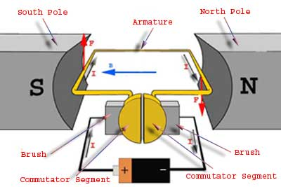

The very basic [construction of a dc motor](http://www.electrical4u.com/construction-of-dc-motor-yoke-poles-armature-field-winding-commutator-brushes-of-dc-motor/) contains a current carrying armature which is connected to the supply end through commutator segments and brushes and placed within the north south poles of a permanent or an electro-magnet as shown in the diagram below.

Now to go into the details of the**operating Principle of dc motor** its important that we have a clear understanding of[Fleming’s left hand rule](http://www.electrical4u.com/fleming-left-hand-rule-and-fleming-right-hand-rule/) to determine the direction of force acting on the armature conductors of dc motor.

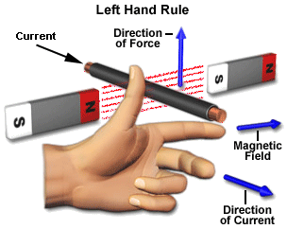

[Fleming’s left hand rule](http://www.electrical4u.com/fleming-left-hand-rule-and-fleming-right-hand-rule/) says that if we extend the index finger, middle finger and thumb of our left hand in such a way that the current carrying conductor is placed in a magnetic field (represented by the index finger) is perpendicular to the direction of current (represented by the middle finger), then the conductor experiences a force in the direction (represented by the thumb) mutually perpendicular to both the direction of field and the current in the conductor.

For clear understanding the **principle of DC motor** we have to determine the magnitude of the force, by considering the diagram below.

We know that when an infinitely small charge dq is made to flow at a velocity ‘v’ under the influence of an electric field E, and a magnetic field B, then the Lorentz Force dF experienced by the charge is given by:-